

Department of Electronics and Communication Engineering

**B.M.S COLLEGE OF ENGINEERING**

(Autonomous College Affiliated to Visvesvaraya Technological University, Belgaum)

Bull Temple Road, Basavanagudi, Bangalore-560019

**PROJECT REPORT**

ON

**ATTENDANCE MONITORING   
SYSTEM USING RFID**

Submitted in partial fulfilment of the requirements for the partial completion of

**Mini Project[19EC3PWMP1]**

IN

**ELECTRONICS AND COMMUNICATION ENGINEERING**

**August - December 2020-21**

SUBMITTED BY:

|  |  |
| --- | --- |
| Adhokshaj Iyengar | 1BM18EC005 |
| Thejas s | 1BM18EC168 |
| Visesh A | 1BM18EC179 |
| Sangamesh V Angadi | 1BM18EC126 |

Under the Guidance of

**Harish V Mekali**

(Assistant Professor, ECE, BMSCE)

**DECLARATION**

We undersigned students of fifth semester B.E in Electronics and Communication Engineering, BMS College of Engineering, Bangalore, hereby declare that the dissertation entitled “ATTENDANCE MONITORING SYSTEM USING RFID”, embodies the report of our project work carried out independently by us under the guidance of Harish V Mekali. Harish V Mekali, Assistant Professor, E&C Department, BMSCE, Bangalore in partial fulfillment for the award of Bachelor of Engineering in Electronics and Communication from Visvesvaraya Technological University, Belgaum during the academic year 2020-2021.

Place : Bangalore

Date : 11/12/2020

ADHOKSHAJ IYENGER 1BM18EC005

THEJAS S 1BM18EC168

VISESH A 1BM18EC179

SANGAMESH V ANGADI 1BM18EC126

**B.M.S COLLEGE OF ENGINEERING**

(Autonomous College under VTU)

**Department of Electronics and Communication Engineering**



**CERTIFICATE**

This is to certify that the project entitled “ATTENDANCE MONITORING SYSTEM USING RFID” is a bonafide work carried out by Adhokshaj Iyenger (USN:1BM18EC005), Thejas S (USN:1BM18EC168), Visesh A (USN:1BM18EC179) and Sangamesh V Angadi (USN:1BM18EC126) in fulfillment for the completion of MINI PROJECT during the academic year 2020-2021 ( Aug’20-Dec’20)

**Guide**

**Harish V Mekali** **Dr. Arathi R Shankar** **Dr. B. V. Ravishankar**

Assistant Prof., ECE, BMSCE HOD, ECE, BMSCE Principal, BMSCE

**External Examination:**  **Signature with date:**

1.

2.

**ABSTRACT**

This project is developed by using Radio Frequency Identification (RFID) system and student card to get student attendance. Before this lecturer needs to use the paper to get the student attendance. There were a lot of problems when using the paper as student attendance such as cheating. This project can help lecturer to reduce the problem like that by design automatic attendance using RFID and student card. The project system was running by get the code of card student to compare with the database in Access. Firstly, lecturer needs to fill forms in an interface like lecturer name, subject and code subject. This part is important because we need the information in this part to use in the next interface. In the next interface, lecturer needs to choose port and speed to make connection with RFID reader. After the reader was ready, process to get attendant will started. Students need to swap their card on the reader and the code from the card will use to compare with database in Access. When the code is match with database, the student information like name and ID number will show on interface and that information will trigger into a list. This list will use as a student attendance. In that list, all information like student name and ID number will attached including the lecturer name and subject. If the code were not match with database, it means that student was in the wrong class or not registers yet in that subject. When this happen, lecturer can register that student by using registering form and the information of that student will be update into database. This project will help lecturer taking the student attendance more easily and automatically. As the conclusion, RFID technology can be used in student attendance application.

**ACKNOWLEDGEMENT**

Any achievement, be it scholastic or otherwise does not depend solely on the individual efforts but on the guidance, encouragement and cooperation of intellectuals, elders and friends. A number of personalities, in their own capacities have helped us in carrying out this project work. We would like to take this opportunity to thank them all.

We express profound gratitude to respected principal **Dr. B. V. Ravishankar,** BMS College of Engineering for providing a congenial environment to work in. Our sincere gratitude to **Dr. Arthi Shankar,** Head of the Department, Electronics and Communication Engineering for encouraging and providing this opportunity to carry out the project in the department.

We would like to thank our guide **Harish V Mekali. Harish V Mekali,** Assistant Professor, Department of ECE who helped us in all the ways to carry out the project work. He stood beside and guided us in every step.

We thank all our professors for providing the basic knowledge without which this project wouldn't have been possible. Last but not the least we thank our family and friends, who made their valuable support compelled us to maintain a standard throughout our endeavour.

ADHOKSHAJ IYENGER

THEJAS S

VISESH A

SANGAMESH V ANGADI

**Contents**

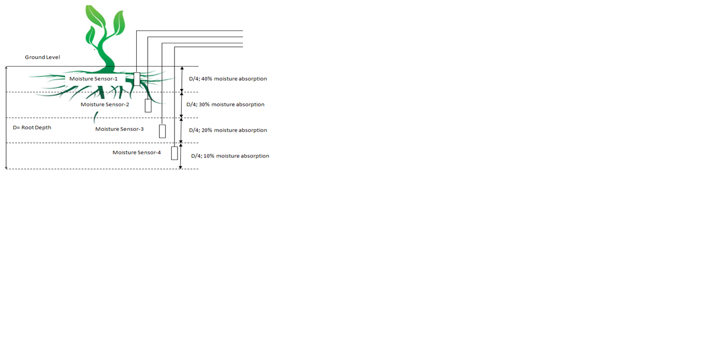

Data acquisition model

SIM900A

Display

Battery

optocoupler

Relay

Soil temperature sensor

Battery level indicator

**TOPIC**  **PAGE NUMBER**

**Chapter 1: Introduction 7**

1.1 Introduction

1.2 Problem definition

1.3 Objective of the project

**Chapter 2: Literature survey 9**

**Chapter 3: Implementation 10**

3.1 Block diagram

3.2 Problem Solution

3.3 Project scope

3.4 Project flow

3.4 Budget

**Chapter 4: Results 12**

4.1 3-D MODEL

4.2 Flow Chart

**Chapter 5: Conclusion and Future Work 14**

5.1 Conclusion

5.2 Future Work

**REFERENCES 15**

**GUIDE AND REVIEWERS COMMENTS 16**

**CHAPTER 1: INTRODUCTION**

* 1. **Introduction:**

RFID (radio frequency identification) is a new technology that incorporates the use of electromagnetic or electrostatic coupling in the radio frequency (RF) portion of the electromagnetic spectrum to uniquely identify an object, animal, or person. RFID tags are not an "improved bar code" as the proponents of the technology would like you to believe. An RFID system consists of three components: an antenna and transceiver (often combined into one reader) and a transponder (the tag). The antenna uses radio frequency waves to transmit a signal that activates the transponder. When activated, the tag transmits data back to the antenna. RFID technology differs from bar codes. RFID can read the tag using RF, meaning that the RFID reader can be read from a distance, right through your clothes, wallet, backpack or purse. Besides the RFID tag consist of unique ID for each tag. The technology used in RFID has been around since the early 1920s. In our country, this technology already been used for several years in certain place such as in Highway using card ‘Touch N Go’ and our government also apply this technology by using RFID as I.C (identification card). Some places, they prefer to used Barcode which is cheaper than RFID. Technology spread very fast. In few years later, there is not impossible if RFID will replace the barcode system in today’s life.

Nowadays, there are lots of universities around our country and each of the university consists of student up to 10 thousand. To handle a large amount of student may be problem especially to get the attendance. Now, process to get attendance in majority universities still used the manual process. The manual process means that when start the class/lecture, lecturer will give a piece of attendance paper and students will check their name and then will sign on it. At the end of class, lecturer will take back the attendance paper and keep it as a record.

Normally, the attendance paper need much time to sign by all students especially for class with a lot of student. Students also forget to sign that attendance and they were assuming absent that class. The problem also will happen when lecturer forget to bring the attendance paper to class. Students need to write their name on a piece of paper and sometimes student will take change to cheat in process getting the attendance. The suitable solution for this problem is by design a system that will record attendance automatically.

In this project, RFID system used to record student attendance automatically. This project will used student ID card as RFID tag and a RFID reader. This RFID system will be integrate with software. This method is more effective to prevent problem in process getting attendance manually.

* 1. **Problem definition:**

Monitoring students’ class attendance in any educational institution is an important process as it is directly linked to academic performance. Collecting the student attendance manually results in loss of precious time, and also delays in subsequent processing of the collected data. So both the students and teachers time is wasted. Most educational institutions' administrators are concerned about student irregular attendance. Truancies can affect student overall academic performance. The conventional method of taking attendance by calling names or signing on paper is very time consuming and insecure, hence inefficient.

**Goals and objectives:**

* A RFID module is interfaced with Arduino UNO with a Wi-Fi module.
* Deployment of a Robust system to ensure better attendance management system.
* Improvise educational institutions with the latest technology.
* Improvement of students attendance.

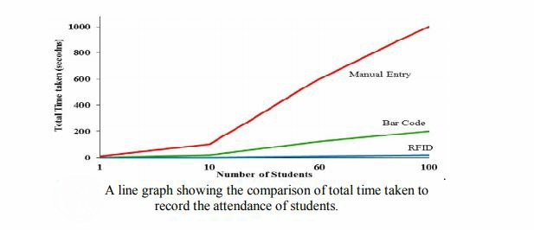

**CHAPTER 2: LITERATURE SURVEY**

The use of Radio-frequency identification (RFID) technology in automated electronic environment and for tracking objects has been widely researched upon by researchers and deployed by various organizations as part of their automation systems. ZhangYuru, Chen Delong and Tan Liping, April, 2013, suggested, The Research and Application of College Student Attendance System based on RFID Technology. Combined with the actual situation of college students class attendance system, the design of student attendance system nodes based on RFID has be proposed. In this paper, the hardware node of system and the develop processes of related application have been detailed presentation. The designed system not only can improve the work efficiency, but also can save human and material resources. Sumita Nainan, Romin Parekh and Tanvi Shah, January 2013, suggested that ―RFID Technology Based Attendance Management System. The proposed framework can give another, precise, and less bulky method for taking understudy participation in school and switch the worldview of understudy's address participation checking in classroom. An ease and cheap RFID Based Authentication System model have effectively created. The model of the framework can give a few advantages over the customary strategy for taking participation. This framework will help in programmed capacity of participation and guardians will be informed in instance of no attendance. In this framework utilizing the AVR controller, guarantees quick operation, cost viability and low power utilization. Ankita Agrawal and Ashish Bansal, ―Online Attendance Management System Using RFID with Object Counter says that, The Student Attendance System using Radio Frequency Identification technology with object counter will significantly improve the current manual process of student attendance recording and tracking system, especially in a university environment. The system promotes a fully-automated approach in capturing the student attendance and monitoring the student in the university campus. The attendance taken is secure and accurate. The system is user-friendly with easily accessible switches and communication ports. Attendance can be stored and retrieved.

**CHAPTER 3: IMPLEMENTATION**

**3.1 Block diagram:**

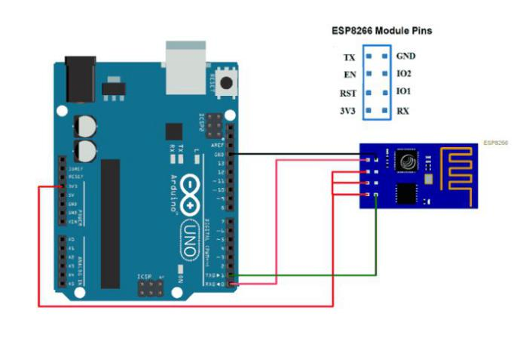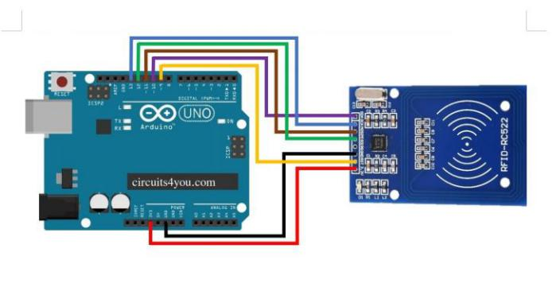

**3.2 Problem Solution:**

* In order to help faculty members concentrate on teaching, a solution is proposed for automated attendance monitoring system.
* With the help of RFID tag we can monitor students’ attendance.
* These RFID tags are embedded into the students ID CARD. As soon as students enter into the respective department he/she taps his/her identity card to the RFID receiver placed.
* They have to tap in again at the end of the day.
* So by this we can ensure that the students attends and the department at a specified time.

## 3.3 Project Scope:

The main goal of this project is develop a student attendance using RFID technology. Two scopes will be cover in this project. Firstly, to use appropriate RFID Tag & Reader for this application. Secondly, is to design GUI to integrate with RFID technology

**3.4 Project Flow:**



**3.5 Budget:**

|  |  |
| --- | --- |
| **Components** | **Cost in Rupees** |
| Arduino UNO | 1,500 |
| Wi-Fi module(ESP8266) | 150 |
| RFID Reader | 100 |
| RFID Tag | 50 |
| M/M , M/F jumper wires | 50 + 50 = 100 |
| Total | Rs: 1,900 |

**CHAPTER 4: RESULT**

**4.1 3-D MODEL:**

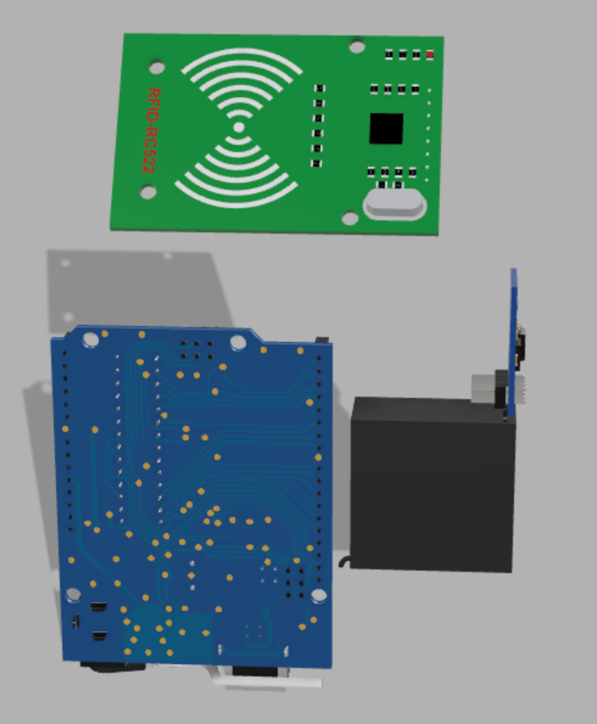

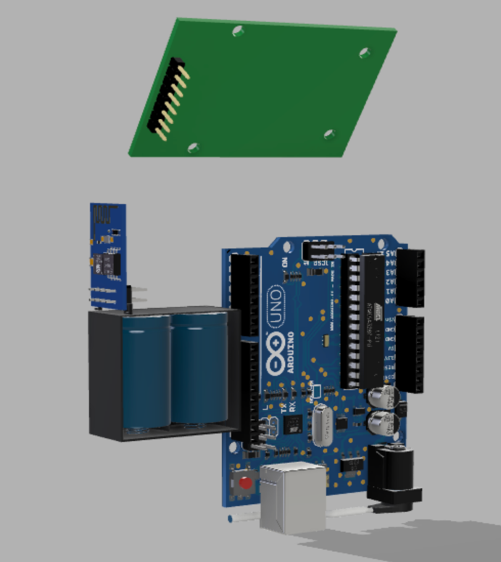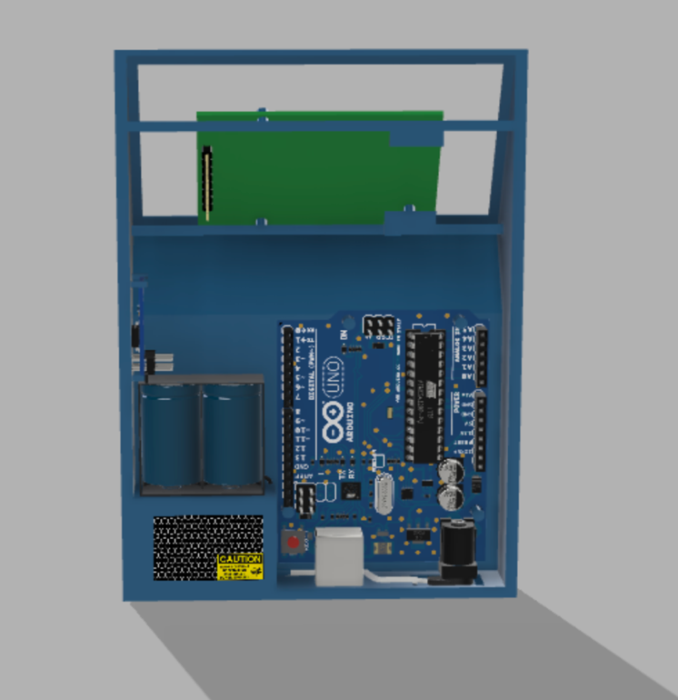

SOURCE: Fusion 360 3-D modelling software.

**4.2 Flow Chart (of working model):**

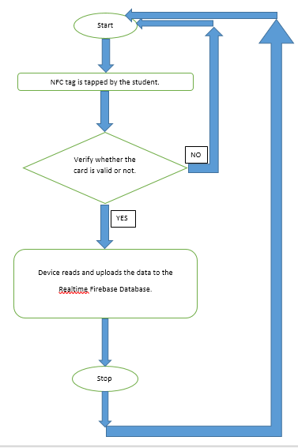

**CHAPTER 5: CONCLUSION AND FUTURE WORK**

**5.1 Conclusion:**

The proposed system can provide a new, accurate, and less cumbrous way of taking student attendance in school and shift the instance of student‘s lecture attendance monitoring in classroom. A low cost RFID Based Attendance System prototype has been successfully developed. The prototype of the system can provide several benefits over the conventional method of taking attendance. This system will help in automatic storage of attendance and parents will be notified in case of absence and it also gives report about their test marks through email.

**5.2 Future work:**

In future some further improvements can be made on this RFID in order to increase its reliability and effectiveness. An indicator or an LCD screen can be incorporated into the system to indicate when any unregistered card is scanned. To prevent actions like buddy-punching wherein a person cheats by scanning for another person the system will be installed where a security guard at the department will be monitoring it. We can make the system more secure by using Hashing & Salting algorithms for our code so that students how may try to hack the system doesn’t get an easy access. The algorithms can be updated every 3 days to make it more secure. The module can only be accessed by the authorised personell for cumulative driver updates and servicing.

**REFERENCES**

[1]. T.S. Lim, S.C. Sim and M.M. Mansor, ―RFID Based Attendance System‖ 2009 IEEE Symposium on Industrial Electronics and Applications (ISIEA 2009), Kuala Lumpur, Malaysia, October 4-6, 2009.

[2]. Zhang Yuru, Chen Delong and Tan Liping, ―The Research and Application of College Student Attendance System based on RFID Technology‖ International Journal of Control and Automation Vol. 6, No. 2, April, 2013.

[3]. Sumita Nainan, Romin Parekh and Tanvi Shah,―RFID Technology Based Attendance Management System‖ IJCSI International Journal Of Computer Science Issues, Vol. 10, Issue 1, No 1, January 2013.

[4]. Ankita Agrawal and Ashish Bansal,―Online Attendance Management System Using RFID with Object Counter‖ International Journal of Information and Computation Technology, ISSN 0974-2239 Volume 3, © International Research Publications House, Number 3 (2013).

* <https://create.arduino.cc/>
* <https://en.wikipedia.org/wiki/Radio-frequency_identification>
* <https://www.electronicsforu.com/category/electronics-projects/hardware-diy>
* <http://www.circuitsforu.com/>

**GUIDE AND REVIEWER COMMENTS**

**GUIDE:**

**REVIEWER:**